1. 2.

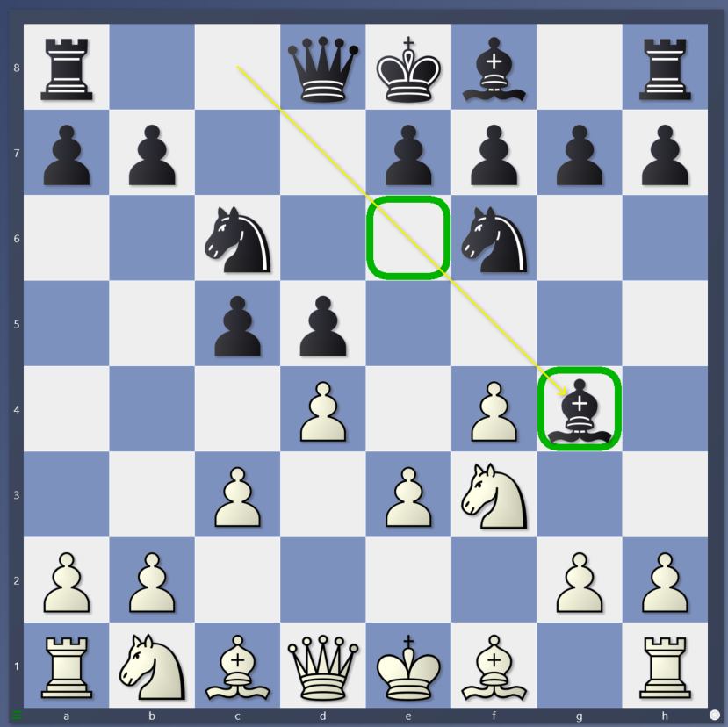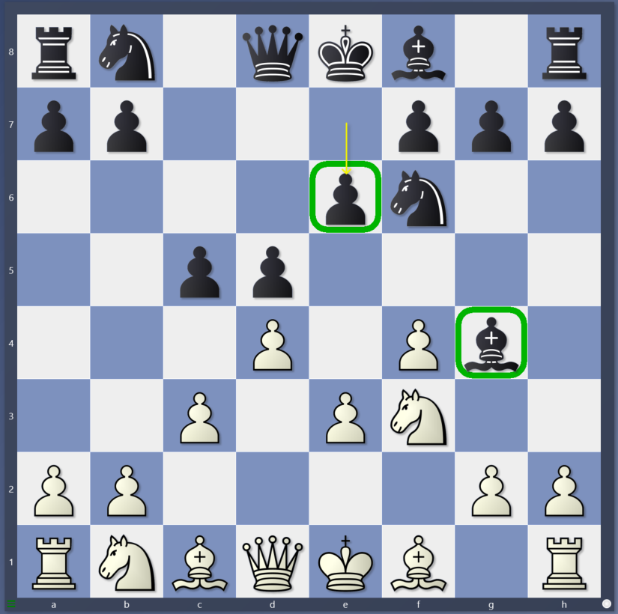

3. 4.

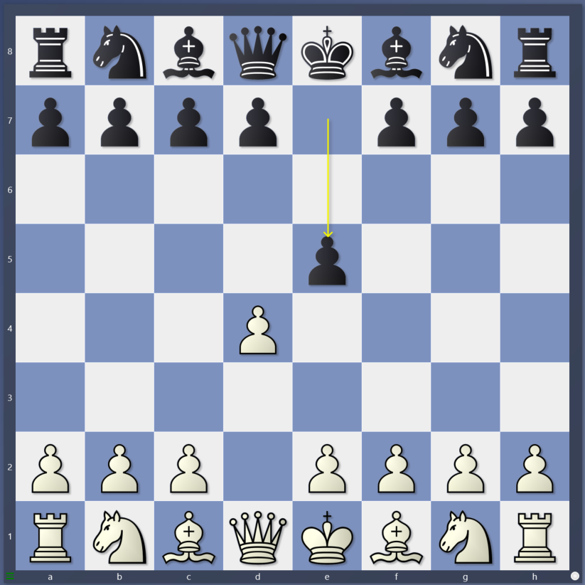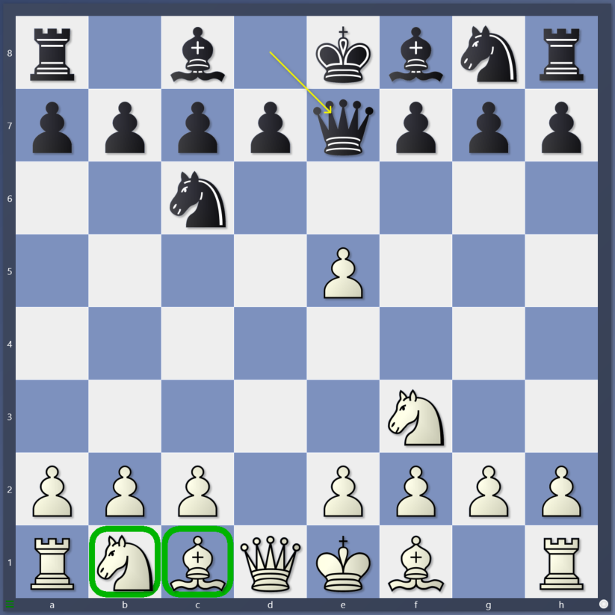

1. If Bg4 without e6, what should white do and why?

2. If Bg4 with e6, what should white do and why? What’s the difference?

3. What opening is this? Should white capture the pawn? What side does white castle on?

4. Should white defend the pawn with the bishop? What are the next 3 moves for white to castle?