1. 2.

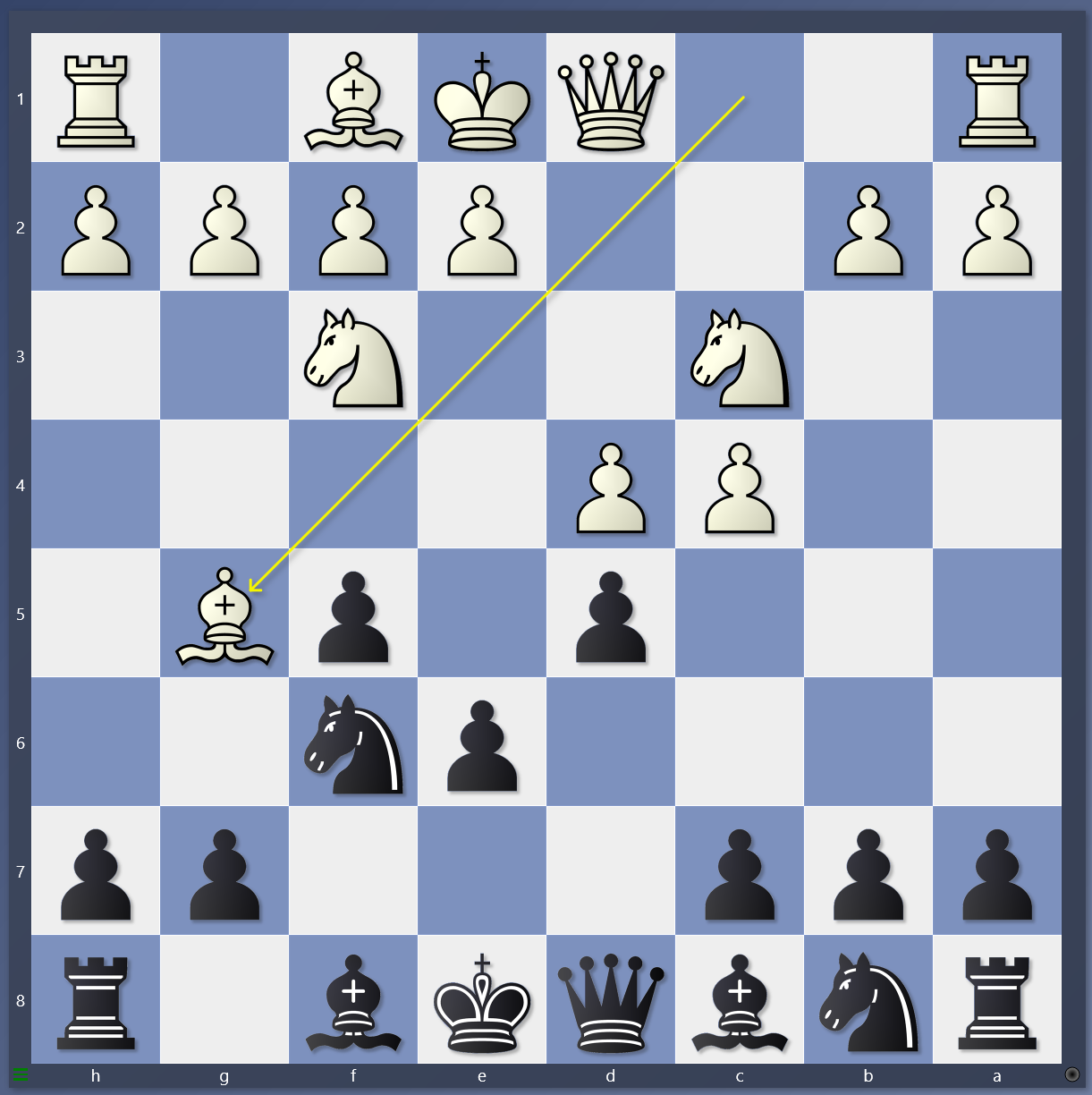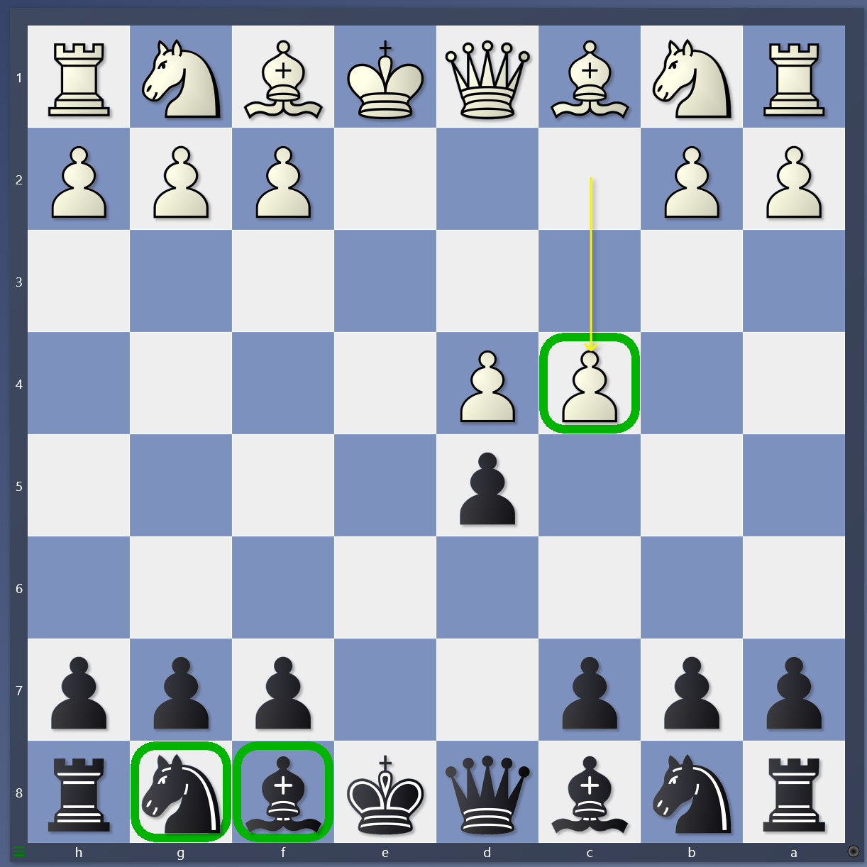

3. 4.

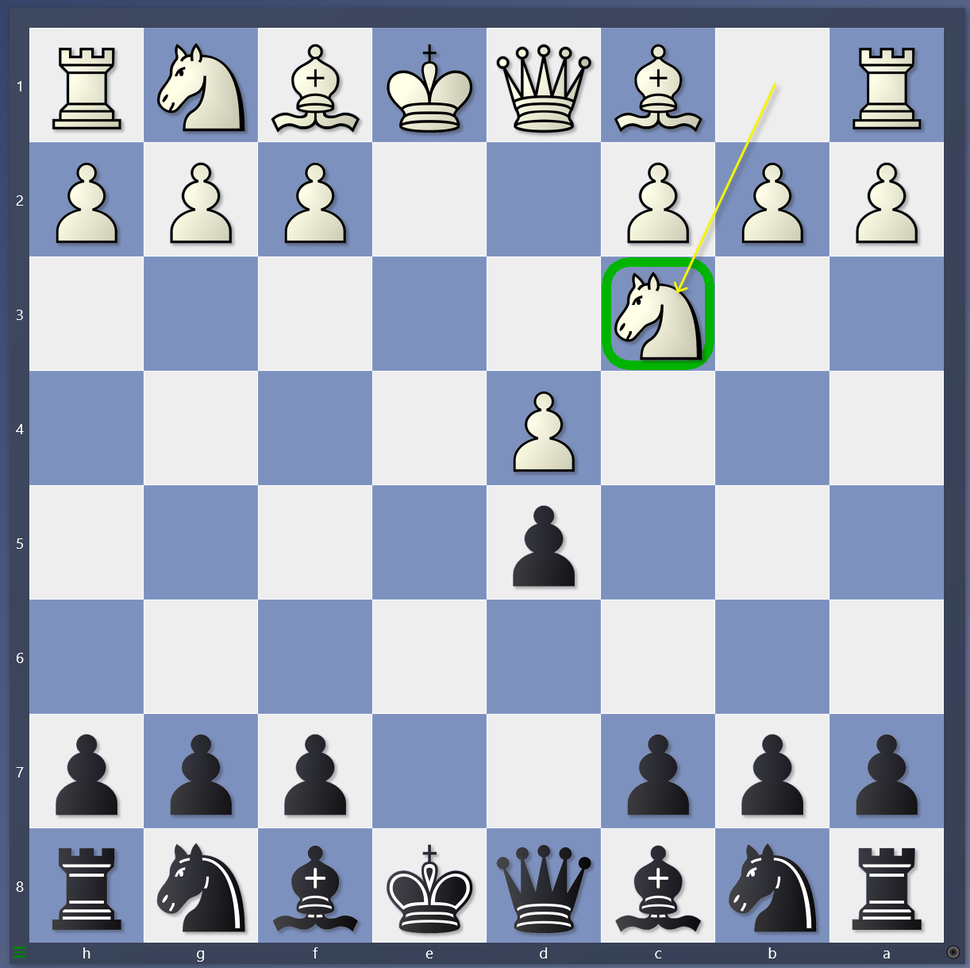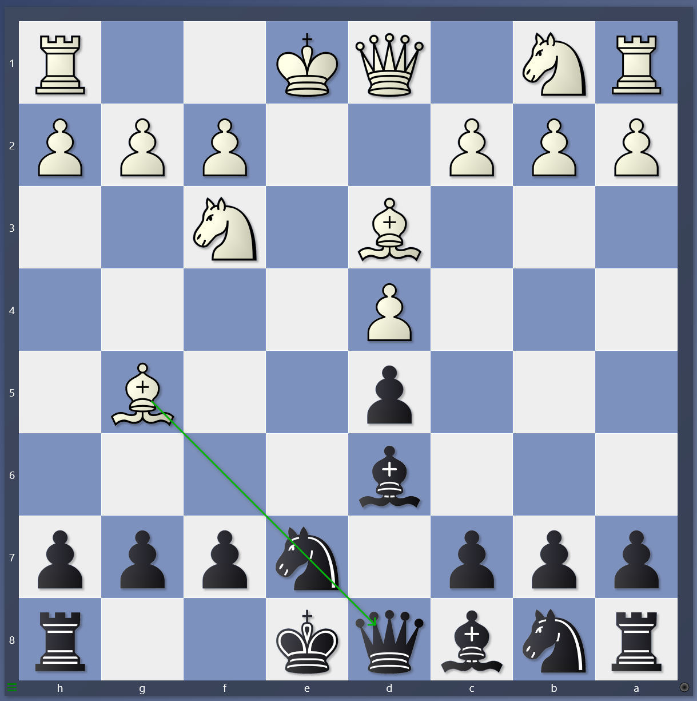

1. What is the next move for black? Before you move the DSB, what should you do?
2. When does black capture the pawn on c4? Where does black develop DSB and g8 Knight?
3. If white plays Nc3, what should black do? Where do the DSB and knight go?
4. If white pins the knight, what should black do? What are the two goals in the opening?