1. 2.

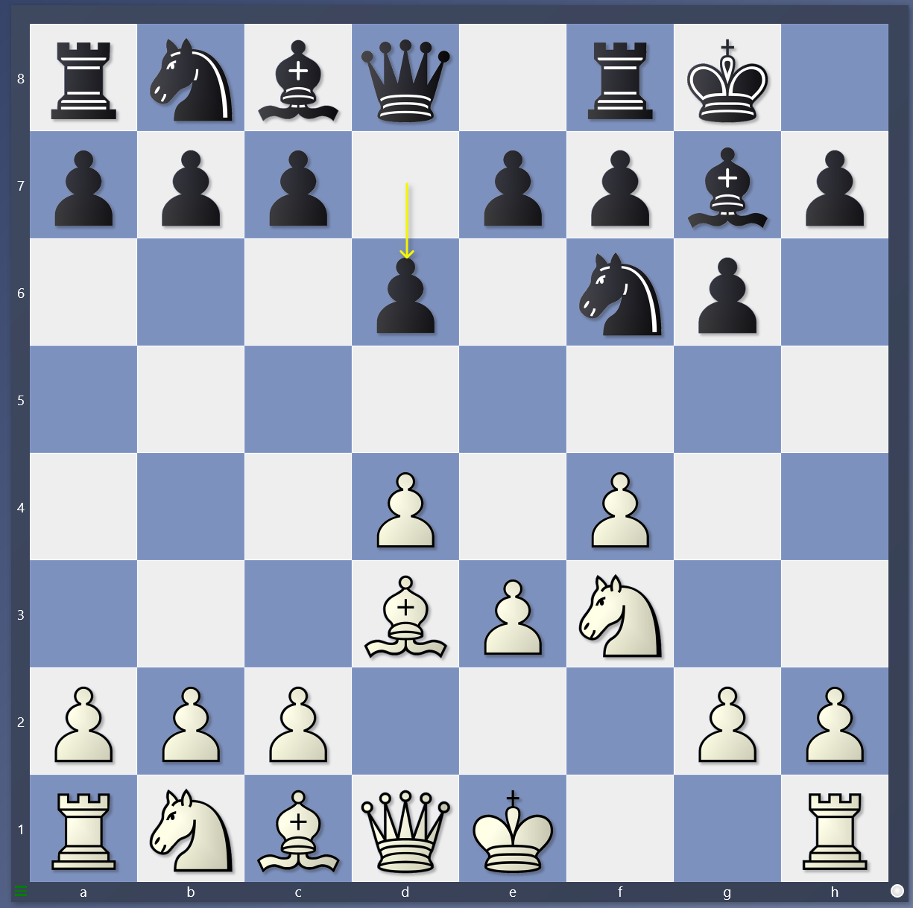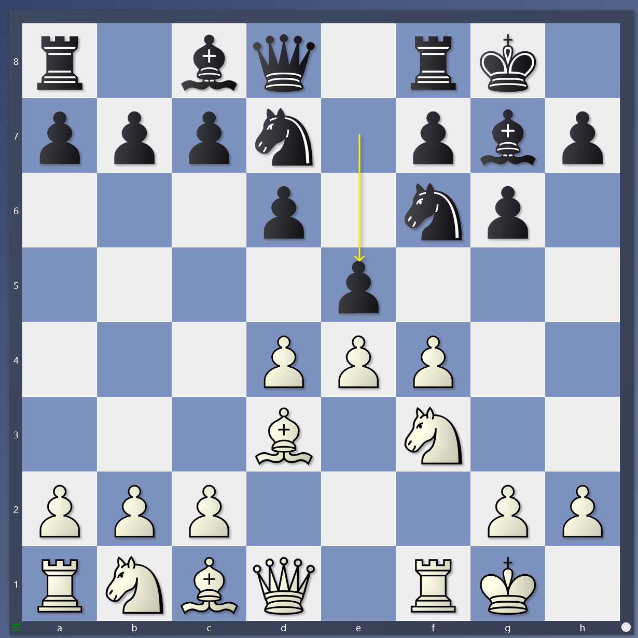

3. 4.

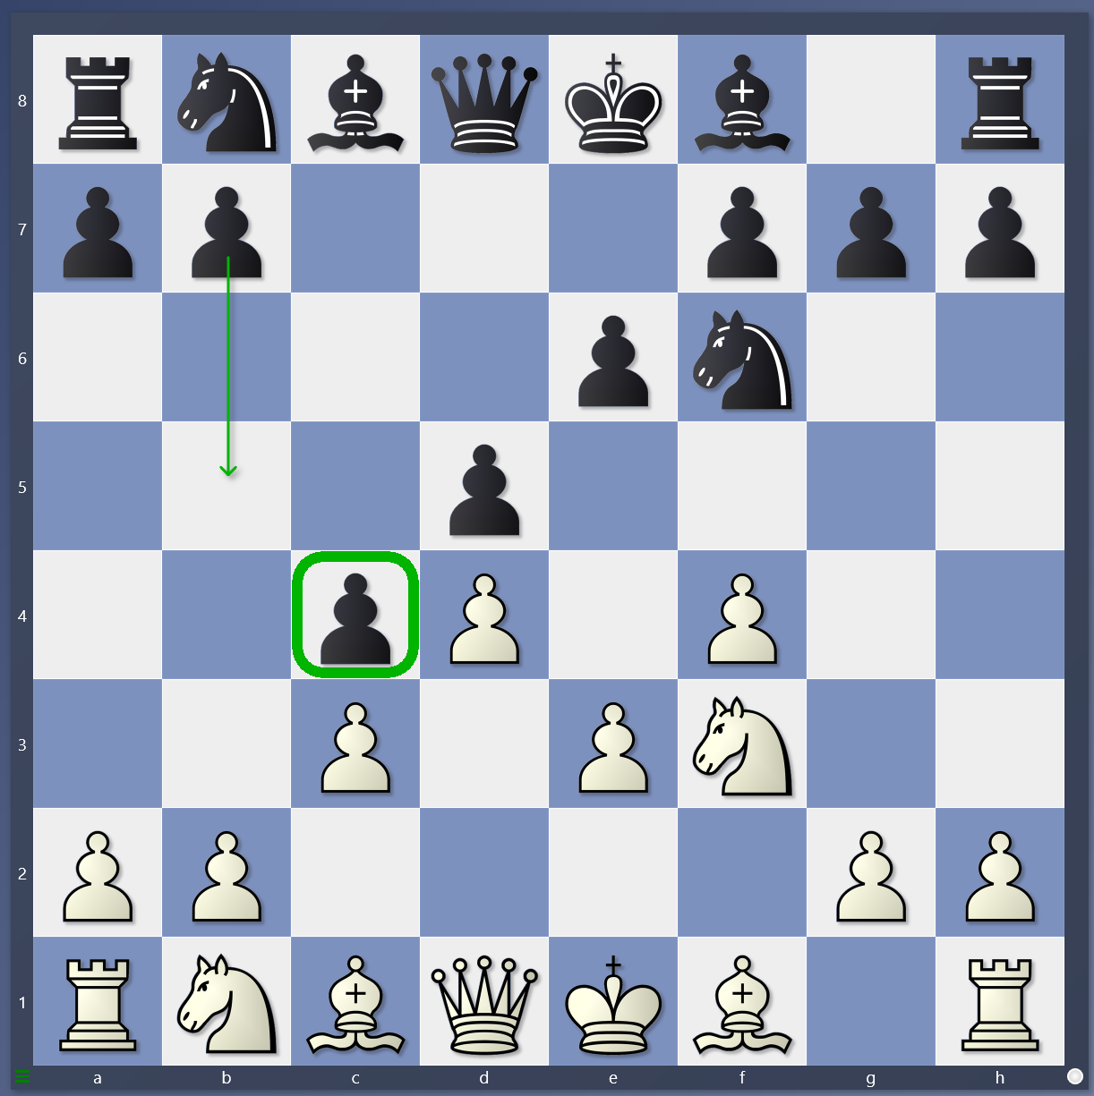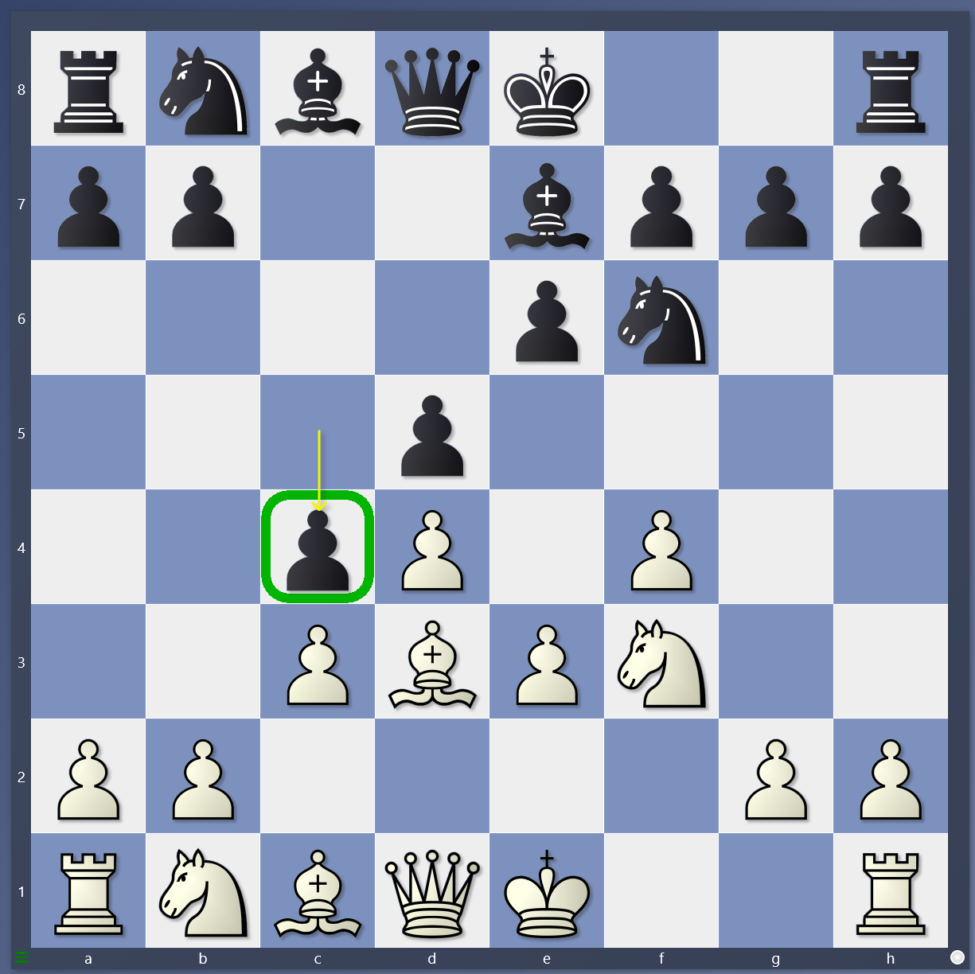

1. If white can’t outpost, what should you do? Do you castle first? When you have space do you keep pushing forward?

2. How do you get the wal-mart position? Do you win the pawn on e5?

3. Is this early c4 or late c4? What should white do? If black plays b5 what does white do?

4. Is this early or late c4? What should white do? Should you outpost and rook lift, or should you push e4? .